EQUIPMENT LIST DATED 06.04.2026
01) Hydraulic Pump-Rauma Brattvaag, PVCLE-450-F170A:-
Hydraulic Pump | 01 Pc.
Hydraulic Pump | Make & Type | Rauma Brattvaag TM / Rolls-Royce Marine AS, PV-CLE-450-F70A-60FF500
Hydraulic Pump | Item No. | 000015128/ABS/NOL022757
Hydraulic Pump | Rev. | B
Hydraulic Pump | Serial No. | 750656
 | CONDITION | UNUSED
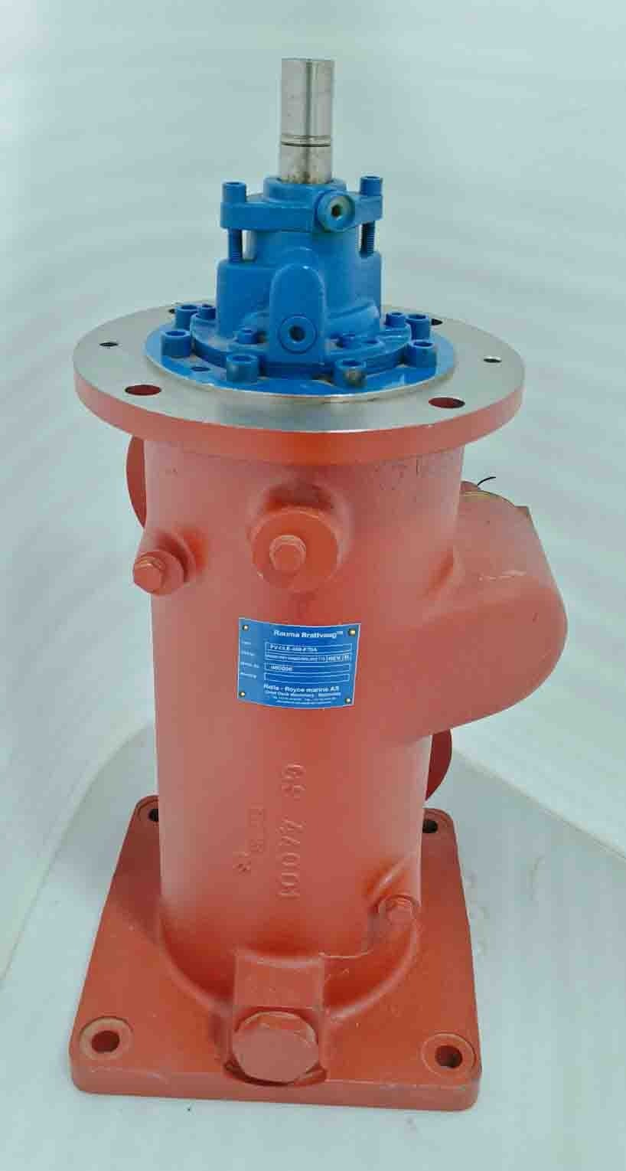

2) J.P.SAUER & SOHN WP 150L-100 Air Compressor With Motor:-
Sr.No. | Description | Qty. Available  (Pcs.) | Condition
01 |  | 01 | Used + Good  (Tested Ok)
  J.P. SAUER & SHON AIR COMPRESSOR WITH MOTOR
  TYPE | WP 150L
  SR.NO. | 81639
  YEAR | 1994
  CAPACITY | 180 M3/H
  PRESSURE | 30 BAR
  SPEED | 1770 RPM
  POWER | 38 KW
  ROTATION | RIGHT
  MOTOR
  VOLTS | 440
  KW | 43
  RPM | 1760
  HZ | 60
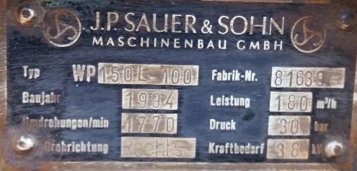
3) Fresh Water Generator-Alfa-Laval, JWP-26-C80:-

Fresh Water Generator | 01 Set
Fresh Water Generator | Make | Alfa-Laval
Fresh Water Generator | Type | JWP-26-C 80
Fresh Water Generator | Capacity | 20 m3/24H
Fresh Water Generator | Item Included | Complete Unit, with Ejector Pump & Control Panel
 | CONDITION | Used + Good  SERVICED & READY TO USE CONDITION

4) FRESH WATER GENERATOR--ALFA LAVAL--JWP-26C-80:-
Fresh Water Generator | 01 Pc
Fresh Water Generator | Make & Type | Alfa-Laval, JWP-26-C80
Fresh Water Generator | Cap. | 20 M3/24 H
Fresh Water Generator | Mfg. Date | 2009
Fresh Water Generator | Complete Unit | Includes F.W.G. with Distillate Pump, PANELS AND EJECTOR PUMP
Condition | Used + Good  FULLY SERVICED PLATES ARE CLEANED AND FITTED WITH NEW ORIGINAL GASKETS & PRESSURE TESTED AT 4-5 BAR  (RE-TESTING SHALL BE CARRIED OUT UPON ORDER CONFIRMATION)

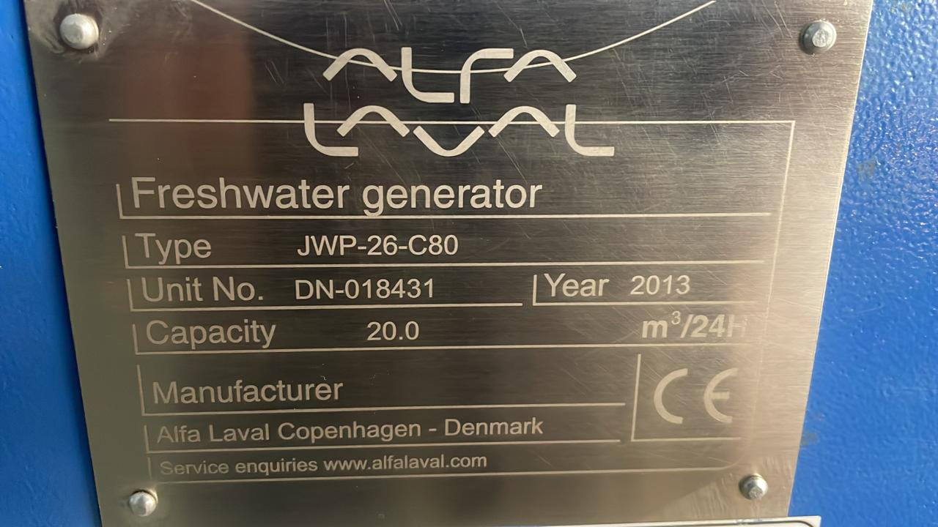
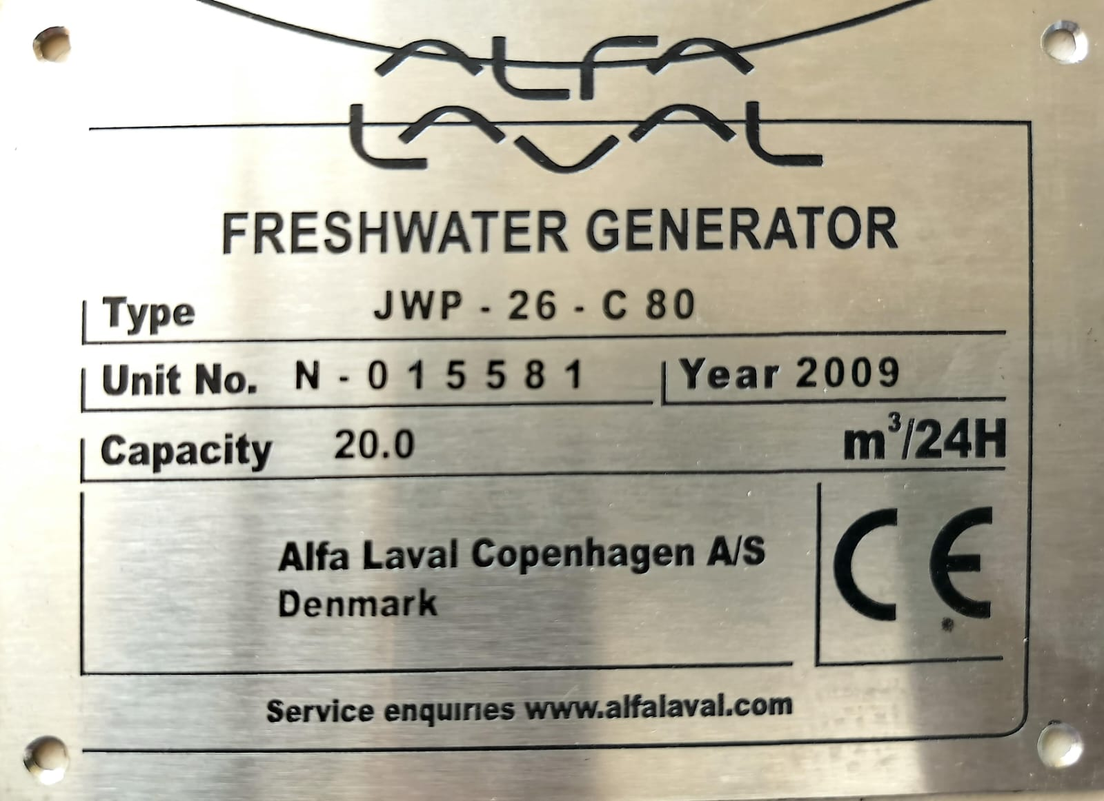

5) HYDRAULIC PUMP-REXROTH, A4VSO500 : -
Hydraulic Pump | 01 Pc.
Hydraulic Pump | Make & Type | Brueninghaus Hydromatik, A4VSO500 dp / 22R-  PPH13N00 - SO504
Hydraulic Pump | Part No. | 00965664
Hydraulic Pump | Year | 03.96
Hydraulic Pump | Serial No. | 1107257 (Made in Germany)
 | CONDITION | USED + GOOD (Serviced, ready to use)
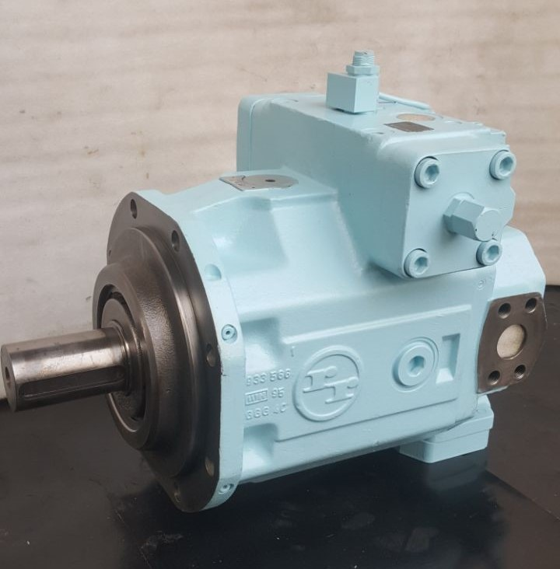
EQUIPMENT LIST DATED 06.04.2026

